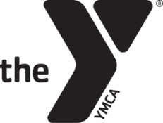
Fremont Family YMCA
Dillon Family Aquatics Center
Water Workout Classes

Monday (before 1 pm) Monday (after 1 pm)
8:00 – 9:00 am Water Workout (Laura) 6:30 – 7:30 pm Hydrocise (Amy)
9:00 – 10:00 am SilverSneaker® Splash (Laura)

Tuesday (before 1 pm) Tuesday (after 1 pm) 8:00 – 9:00 am Into the Deep (Michelle) No classes

Wednesday (before 1 pm) Wednesday (after 1 pm)
8:00 – 9:00 am Water Workout (Laura) 6:30 – 7:30 pm H2O Body Sculpt (Jamie)
9:00 – 10:00 am SilverSneaker® Splash (Laura)

Thursday (before 1 pm) Thursday (after 1 pm)
8:00 – 9:00 am Water Boot Camp (Rhonda) No classes

Friday (before 1 pm) Friday (after 1 pm)
8:00 – 9:00 am Water Workout (Laura) No classes
9:00 – 10:00 am SilverSneaker® Splash (Laura)

*** Thursday evening will now have ‘Open Swim’***
Please note the Dillon Family Aquatics Center hours are a little different from the main building. There are a few dates where the Aquatics Center will be closed for swim meets.
Ask to join our Fremont Family YMCA Group Fitness Facebook group AND download our APP (Fremont Family YMCA) for all updates/cancelations/motivation.

