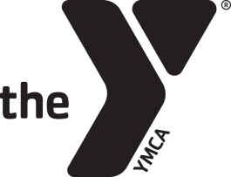
Fremont Family YMCA
www.fremontfamilyymca.org
Gymnastics Birthday Party Agreement Form

Child’s Name_________________________________________ Age____________________
Contact Person_________________________________________________________________
Phone # ______________________________ # in Party________________________________
Members
$100
Non-Members
$150
Party Date
Month___________ Day____________
Party Time
Saturday Sunday
1pm-2pm 1pm – 2pm
2pm-3pm 2pm-3pm
3pm – 4pm 3pm-4pm
4pm-5pm 4pm-5pm

Signature__________________________________________ Date_________________

All gymnastics birthday must go through Jensen Sullivan, Gymnastics Director. Please fill out the information above after a date and time have been agreed upon and return it to the front desk. The full balance needs to be paid 24 hours prior to your party. If you have any questions, please call Jensen at 402-721-6952.

