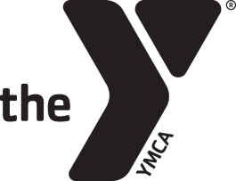
Gymnastics Birthday Party Agreement Form
Fremont Family YMCA
www.fremontfamilyymca.org
402.721.6952

Child’s Name_____________________________________________________________ Age____________________
Contact Person_______________________________________________________________________________________
Phone # _________________________________________________ # in Party________________________________
Email Address________________________________________________________________________________________
FFY Members
1-15 children: $100
16-30 children: $150
Non-Members
1-15 children: $175
16-30 children: $225
Parties include one hour in the gymnastics center with a party coordinator and 30 minutes in the Tennis Viewing area to open gifts and eat cake. The gymnastics viewing area will be available for 15 minutes before and 15 minutes after the party for set up/clean up.
Party Date: Month_____________________________ Day____________
Party Time
Saturday Sunday
10:30am-Noon 12:45pm-2:15pm
12:30pm-2:00pm 2:45pm-4:15pm
2:30pm-4:00pm 4:45pm-6:15pm
4:30pm-6:00pm
Signature_____________________________________________________________ Date_________________

All gymnastics birthday must go through Andrea Neahous, Birthday Party Coordinator, or Jensen Sullivan, Gymnastics Director. Please fill out the information above after a date and time have been agreed upon and return it to the front desk. The full balance needs to be paid 24 hours prior to your party. If you have any questions, please contact Andrea at events@fremontfamilyymca.org, or Jensen at jensens@fremontfamilyymca.org.

