FREMONT FAMILY YMCA www.fremontfamilyymca.org
F.A.S.T. (Fremont Area Swim Team)
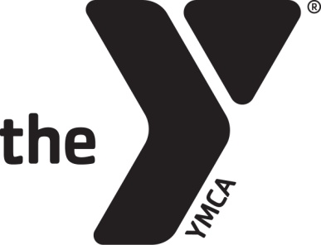
SWIM TEAM

FALL SEASON OPEN HOUSE/TEAM ORIENTATION WEEK
AUGUST 19th – 22nd

5:30-6:30 pm F.A.S.T. Registration Available, Practice Times Provided, Ask Questions, and Meet Coaches!
(SW side of pool deck at deep-end)
6:30-7:30 pm Light Swim Practice (0-5 lanes), Stroke Analysis (6-11 lanes)
Family members will watch from the balcony.

ALL CURRENT AND FUTURE F.A.S.T. MEMBERS ARE ENCOURAGED TO ATTEND!

Our Fall Season Kick-Off to Training!
Will allow present/new/potential F.A.S.T. team members to participate in the Fall Season Kick-Off!

• FFY member to participate with F.A.S.T. (Scholarship/Financial Aide Available.)
• New swimmers must be able to swim the length of the pool unassisted in at least one stroke to the coach’s satisfaction to join.
• F.A.S.T. is both a YMCA and USA Swimming competitive swim team.
• Sign up at https://www.teamunify.com/team/mwfast/page/home

F.A.S.T. Swim Team Groups
Bronze – Swim Team Beginner Swimmers
Silver – Swim Team Intermediate Swimmers
Gold – Swim Team Advanced Swimmers
Senior – High School & College Swimmers

F.A.S.T. Monthly Fees/Group
Bronze group cost (participants determined by age and/or ability)
$30 per month per swimmer
Silver group cost (participants determined by age and/or ability)
$40 per month per swimmer
Gold group cost (participants determined by age and/or ability)
$70 per month per swimmer
Senior group cost (high school swimmers)
$105 per month per swimmer

• Financial assistance is available on monthly fees. A discount is available for swimmers on free or reduced lunches.
• One-time fall/winter season USA Swimming registration fee of $70, a one-time fall/winter season YMCA Swim League fee of $10 and first month team dues is charged per swimmer when registering.
• Coach Eric Shanks, Swim Team Program Director, 402-753-9854, erics@fremontfamilyymca.org

YMCA MISSION: God has given us the pathway to life and health through Jesus Christ and the Holy Scriptures.
It is the mission of the Fremont Family YMCA to help put these Christian principles into practice through programs that help build healthy spirit, mind and body for all.
NO YOUTH DENIED: Any child may belong to the YMCA regardless of income or family situation. If you know of a child who would like to belong, please notify the YMCA staff.

