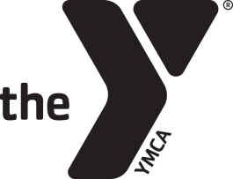
Tennis Birthday Party Agreement Form
Fremont Family YMCA
www.fremontfamilyymca.org
402.721.6952

Child’s Name_____________________________________________________________ Age____________________
Contact Person_______________________________________________________________________________________
Phone # _________________________________________________ # in Party________________________________
Email Address________________________________________________________________________________________
FFY Members
1-15 children: $100
16-30 children: $150
Non-Members
1-15 children: $175
16-30 children: $225
Parties include thirty minutes with a tennis pro on the courts and 60 minutes in the party area to open gifts and eat cake. The party area will be available for 15 minutes before and 15 minutes after the party for set up/clean up.
Party Date: Month_____________________________ Day____________
Party Time
Saturday Sunday
10:30am-Noon 12:45pm-2:15pm
12:30pm-2:00pm 2:45pm-4:15pm
2:30pm-4:00pm 4:45pm-6:15pm
4:30pm-6:00pm
Signature_____________________________________________________________ Date_________________

All tennis birthday must go through Kerri Pentel, Director of Tennis. Please fill out the information above after a date and time have been agreed upon and return it to the front desk. The full balance needs to be paid 24 hours prior to your party. If you have questions, please contact Kerri at kerrip@fremontfamilyymca.org.

