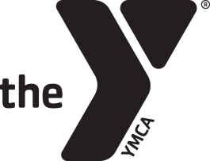
Underground Birthday Party Agreement Form
Fremont Family YMCA
www.fremontfamilyymca.org
402.721.6952

Child’s Name_____________________________________________________________ Age____________________
Contact Person_______________________________________________________________________________________
Phone # _________________________________________________ # in Party________________________________
Email Address________________________________________________________________________________________
FFY Members
1-15 children: $100
16-30 children: $150
Non-Members
1-15 children: $175
16-30 children: $225
Parties include 60 minutes in the Underground with a party coordinator and 30 minutes in the party area to open gifts and eat cake. The party area will be available for 15 minutes before and 15 minutes after the party for set up/clean up. This room is available for children 8 years old and up. Please remove any decorations that are put up prior to leaving.
Party Date: Month_____________________________ Day____________
Party Time
Saturday
10:30am-Noon
12:30pm-2:00pm
2:30pm-4:00pm
4:30pm-6:00pm
Signature_____________________________________________________________ Date_________________

All Underground parties must go through Andrea Neahous, Birthday Party Coordinator or Kylie Brown, Director of Before/After School Care. Please fill out the information above after a date and time have been agreed upon and return it to the front desk. The full balance needs to be paid a week prior to your party. If you have questions, please contact Andrea at events@fremontfamilyymca.org or Kylie at kylieh@fremontfamilyymca.org.

